**1.Facebook Gathers Companies to Back Cryptocurrency Launch.**

Facebook, Inc. ([FB](https://www.investopedia.com/markets/quote?tvwidgetsymbol=fb)) has big plans to unveil its new platform cryptocurrency next week, with a launch slated for next year, according to a detailed report by the [**Wall Street Journal**](https://www.wsj.com/articles/facebooks-new-cryptocurrency-gets-big-backers-11560463312). Users of the social media platform will be able to send the digital coin, called Libra, to one another, and they will also be able to use it to make purchases both through Facebook and across the internet more broadly.

In order to build support for the new coin project from its earliest stages, Facebook has enlisted the financial backing of more than a dozen companies across the financial, e-commerce, tech and telecommunications industries. Push-back from regulators and digital currencies advocates alike, however, has put into question when, and indeed if at all, **Libra** will make its public debut.

KEY TAKEAWAYS

* Libra is the much-hyped digital currency proposed by Facebook to be used within its online ecosystem.
* Libra is intended to be a 'stablecoin' that is pegged to a basket of global currencies including the US dollar, Euro, and Yen.
* Heavyweights in the payments space such as Mastercard and PayPal, among others, have signed on as corporate partners and sponsors of the Libra project.
* Regulators in the EU and US, however, have raised concerns and red flags over Libra's potential risks and may squash its release.

# 2. New study allows brain and artificial neurons to link up over the web.

During the study, researchers based at the University of Padova in Italy cultivated rat neurons in their laboratory, whilst partners from the University of Zurich and ETH Zurich created artificial neurons on Silicon microchips. The virtual laboratory was brought together via an elaborate setup controlling nanoelectronic synapses developed at the University of Southampton. These synaptic devices are known as memristors.

The Southampton based researchers captured spiking events being sent over the internet from the biological neurons in Italy and then distributed them to the memristive synapses. Responses were then sent onward to the artificial neurons in Zurich also in the form of spiking activity. The process simultaneously works in reverse too; from Zurich to Padova. Thus, artificial and biological neurons were able to communicate bidirectionally and in real time.

**Themis Prodromakis**, Professor of Nanotechnology and Director of the Centre for Electronics Frontiers at the University of Southampton said "One of the biggest challenges in conducting research of this kind and at this level has been integrating such distinct cutting edge technologies and specialist expertise that are not typically found under one roof. By creating a virtual lab we have been able to achieve this."

## [3.Blockchain is emerging from the shadows and making its way into a murky future. Don’t count it out.](https://www.nytimes.com/spotlight/dealbook-special-section)

[[](https://www.nytimes.com/spotlight/dealbook-special-section)](https://www.nytimes.com/spotlight/dealbook-special-section)

You’ve probably heard that the blockchain is a technology that is going to change the world — it is the backbone of Bitcoin, the now infamous cryptocurrency. You might even have heard someone trying to explain blockchain by describing it as a “[trusted distributed ledger.”](http://www.finra.org/sites/default/files/2017_BC_Byte.pdf)

Meanwhile, Fortune 500 companies are investing billions in the blockchain. IBM has a whole division focused on blockchain, as do the consultancies Accenture and PwC. Jamie Dimon, JPMorgan Chase’s chief executive, has dismissed Bitcoin, but says “the blockchain is real.”

Silicon Valley venture capitalists have already sunk more than $1.3 billion into blockchain technology just this year. And just this week, Andreessen Horowitz, one of the most prominent technology firms founded, in part, by Marc Andreessen — who is credited with inventing the modern Web browser — announced a $300 million “crypto” fund to exclusively invest in blockchain technologies

The blockchain is ultimately about solving society’s ultimate challenge: trust. Or rather, lack of trust. Blockchain is about using technology to create a shared sense of trust by a group of disparate participants.

The biggest question is whether the hundreds of projects like Decentraland, where individuals are using real money to buy virtual property, will end well or badly — and whether that experience will ultimately instill or undermine trust in this emerging technology.

# 4. Neo3 Exception Handling Mechanism

# https://miro.medium.com/max/800/1*_ojSkzPMuUKnmQGyeYnp1g.jpeg

# What’s Exception?

Exceptions are abnormal events that occur while the program is running such as divide by 0 overflow, array index over bounds, nonexistent contract call, etc.

A well-designed program should provide methods for handling exceptions when they occur, so that the program does not block or produce unexpected results because of the occurrence of exceptions. For example, if a payment is insufficient or fails, we need to resume other operations.

**Exception Handling Mechanism**

Before the exception mechanism was introduced, exceptions were often handled by if-else. However, this method of handling exceptions is troublesome. If the same exception or error occurs in more than one place, the same processing should be done everywhere, resulting in many redundant codes with the same function.

# 5. Exploring Server-Driven UI

## “A new way to build reactive apps with native UI”



Native apps are still the first choice for businesses that want to expand at scale and reach out to millions based on their UI and performance. This statement might be controversial for many of the people out there, but we’re not going to discuss which platform is best. Instead, we’re going to learn how to grab more control over what you’re showing in the app using server-driven UI.

**What Is Server-Driven UI?**

Server-driven UI is when the API tells the client what components to render and with what content. This can be implemented in all three major platforms: Android, iOS, and the web. In my opinion, this type of development makes native apps more reactive and controllable.

**How Can a Server Control UI?**

Theoretically, it’s simple: We make a request to a server and then we receive a JSON response in which there will be logic for what to inflate on the screen. Based on the logic, we have to render natively developed UI components on the view. This results in a high-quality user experience and allows more control for the companies over what users can see.

6. Remote Development with Pycharm

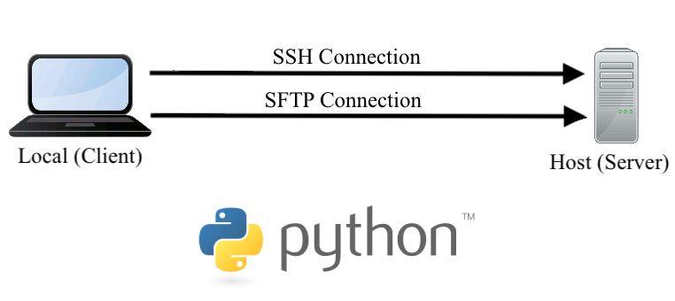

[Pycharm](https://www.jetbrains.com/pycharm/) is a great IDE — complete with features that promote [productive programming](https://www.jetbrains.com/pycharm/features/), a community devoted to sharing clever [plug-ins](https://plugins.jetbrains.com/pycharm), and, my personal favorite trait, [Professional licenses are free to students](https://www.jetbrains.com/community/education/#students). With this, [JetBrains toolbox](https://www.jetbrains.com/toolbox-app/" \t "_blank) with its many IDEs (one for most modern computing language) is available to students free of charge (no strings attached). Bravo, [JetBrains](https://www.jetbrains.com/" \t "_blank)! Free for students is a service that more products should embrace.

**WORKING REMOTELY VIA PYCHARM**

With the [Coronavirus](https://www.who.int/health-topics/coronavirus" \t "_blank) now an international concern, a vast percentage of professionals must work remotely. As someone set up an iMac (i.e., local machine) to work in sync with a PC running Ubuntu (i.e., remote host), the next step is to configure PyCharm to edit locally and run remotely. There are many reasons one may want to do this — our motivation is to easily deploy jobs to the remote host with GPUs.

# Set up a Remote Host

Setting up a Remote Host via PyCharm’s Deployment tools is quite simple (i.e., as most features offered by PyCharm tend to be). For this, a few words would suffice. Nonetheless, prepared in this tutorial are detailed steps to ensure clarity. Let’s begin!

Specifically, we aim to set an [SFTP](https://www.ssh.com/ssh/sftp) connection, which is a secure file transfer schema that runs over SSH protocol. For this, we must know

1. The [IP address](https://computer.howstuffworks.com/internet/basics/what-is-an-ip-address.htm) of the host, which is accessible via the [ifconfig](https://www.linuxtrainingacademy.com/determine-public-ip-address-command-line-curl/" \t "_blank) bash command.
2. The username on the host (at the respective IP address from (1))
3. The password or an [SSH key](https://www.ssh.com/ssh/key) (for simplicity, the password will be used here — future blog could be on SSH keys).